**Code Overview**

# 

# 

# 1. Projektstruktur

## C-Project (see Section 2 and 3.2)

* Source code of the C++ project running on the ActivityBots
* uses the Library PopWare
* Follows the lines on the floor and waits for commands from the PC

## Routing Table (see Section 2 and 3.1)

* Source Code of the Kotlin/Java Project running on the PC
* Manages communication between Bots and PC
* Executes the Algorithm and sends instructions to the individual Bots

## Barcode Encoder

* Helper project to automatically generate printable roundabout segments
* Encodes the given node ID into a barcode and saves it into a svg or pdf file
* InkScape must be installed for the conversion from svg to pdf

## Ant Shield

* 3d-printable shield for improving the performance of the LineFollower
* Blocks incoming light from the sides and therefore improves the detection rate of the black lines
* Available as Creo Part, Step and STL

## Printables

* This folder contains all printable rail-segments that make up the map the Ants drive on
* The segments have to printed on A3 Paper, cut to size, optionally they can be laminated to improve longevity
* Additionally, a printable calibration strip is given to check how well the LineFollower is working
* The individual sensors should only kick on in the center of the strips, otherwise it has to be recalibrated
* A representation of the map shown in the demo video can be found in the file 2013Map.xlsx

## Documentation

* Further documentation
* Overview of the code with project structure as well as relevant code segments
* Assembly instructions of the ActivityBots hardware

# 2. System Overview

**Routing Table (Kotlin)**

# 3. Relevant code segments for changes

Communication over TCP with own Messages-Framing

* Wifi-Handler in ThreadPool
* Encoding and decoding of messages
* Automatic reconnect
* Timeout of Ants using regular pings

Graphical interface

* Chart
* Graph
* Speed-Control

**GUI**

**Communication**

**Data**

**Real Ant (C++)**

**Line-Follower**

**Communication**

* Wifi-Connectivity using external ESP8266
* Encoding and decoding of messages
* Automatic answer to ping-requests
* Line detection using infrared-diodes (B/W)
* Line keeping using PI-Controller
* Collision avoidance using Ultrasonic distance sensor
* Reading and decoding the barcodes
* Real + virtual ants
* ACO-Algorithm
* Representation of the graphs

## **3.1 Routing Table – Server (Kotlin)**

* Connection Settings (IP-Space of the Bots)
  + de.jonasnick.antnet.routingtable.communication.ConnectionManager
    - prefix
* Predefined constants of the Algorithm
  + de.jonasnick.antnet.routingtable.data.AntConstants
* Predefined map
  + de.jonasnick.antnet.routingtable.data.map.Maps
* Function for setting the pheromones on target arrival
  + de.jonasnick.antnet.routingtable.data.map.Connection
    - copyWithAdjustedPheromones
* Function for pheromone evaporation in each tick
  + de.jonasnick.antnet.routingtable.data.AntManager
    - tick -> “nodeManager.updateAllConnections”
* Function for selecting the next edge to follow
  + de.jonasnick.antnet.routingtable.data.ants.AbstractAnt
    - selectNext

## **3.2 ActivityBot – Client (C++)**

* Parameter of the PI controller
  + src\programms\linefollower\linefollower.h
    - LineFollower::KID
  + src\programms\linefollower\linefollower.cpp
    - LineFollower::KP
* Min distance of the ultrasonic sensors
  + src\programms\linefollower\linefollower.h
    - MIN_DISTANCE
* Controller for line keeping
  + src\programms\linefollower\linefollower.cpp
    - LineFollower::run (Zeilen 135-200)
* Processing of a read barcode
  + src\programms\linefollower\linefollower.cpp
    - LineFollower::barcodeCallback
* Reading of a barcode
  + src\programms\linefollower\linefollower.cpp
    - LineFollower::run (Zeilen 240-300)

# 4. ActivityBot + PropWare

Propware and this project can be executed on the ActivityBots using the the following instructions:

1. Installation of PropWare using the following instructions  
   <https://david.zemon.name/PropWare/#/download>
2. Installation of MinGW, to be able to use make   
   <http://www.mingw.org/>
3. When using *Jetbrains CLion:* Configuration of the Toolchain as shown:  
   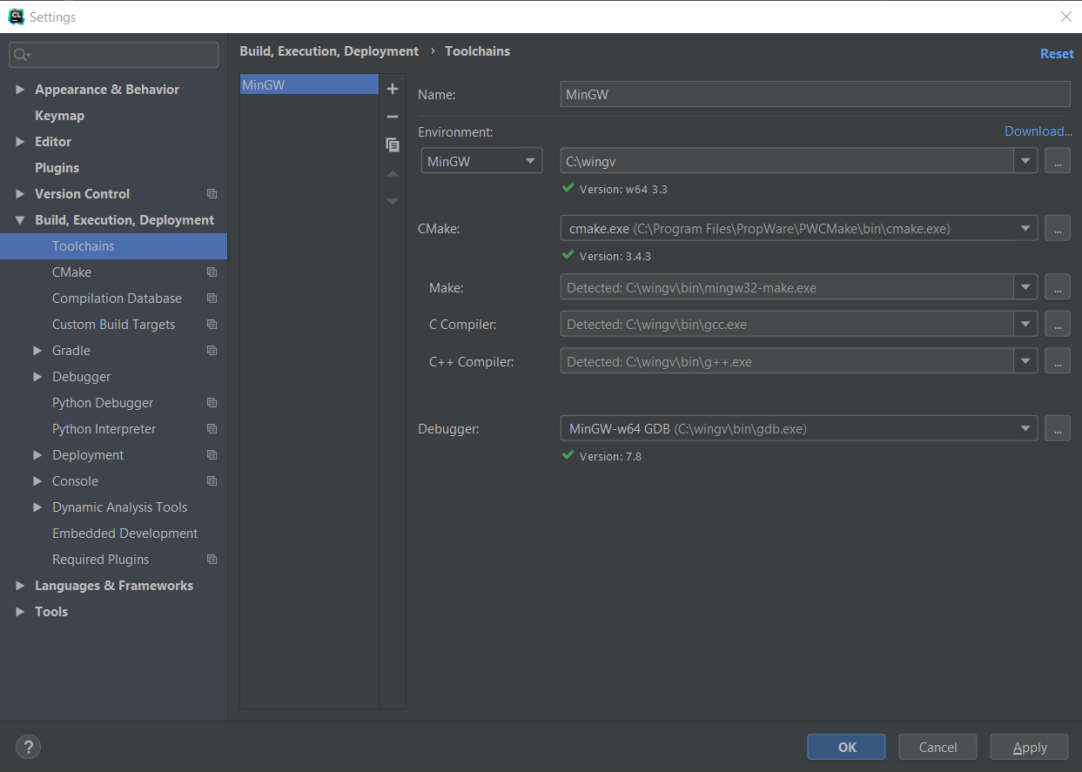
4. Creation of a /bin directory and changing into it
   1. mkdir bin
   2. cd bin
5. Execution of the command (only has to be executed again on changes to CMakeList.txt)
   1. cmake -G "Unix Makefiles" ..
6. Connect an Activity Bots and set the switch it to Mode 1
7. Execute one these commands (still in /bin directory)
   1. make debug  
      To flash the bots in the RAM.   
      Program doesn’t persist after switching the bot on and off
   2. make debug-eeprom  
      To flash the bots in the EEPROM.  
      Program persists even after shutdown or reset